DESIGN AND DEVELOPMENT OF A WEB-BASED
MANTILLA FUNERAL RESERVATION SYSTEM

Final System Project Documentation Paper

In Partial Fulfillment of the Requirements
for the course subject of IT 312 System
Integration and Architecture 2

By:
Mantilla, Mark Bryan A.

Mr. Jeremiah Dela Cruz
Adviser

MAY 2026
TABLE OF CONTENTS
Title Page i
List of Figures iv
List of Tables v
Introduction 1
Objectives 4
General Objective 4
Specific Objectives 4
Scope and Limitations 5
System Description 6
Technologies Used 7
System Design 8
Use Case Diagram 8
Flowchart 9
ER Diagram 10
System Architecture Diagram 11
Interface Design 12
Database Structure 26
Implementation and Testing 30
Conclusion 32
Recommendations 33

LIST OF FIGURES
Figure 1. Use Case Diagram 8
Figure 2. Flowchart 9
Figure 3. ER Diagram 10
Figure 4. System Architecture Diagram 11
Figure 5. Interface Design 12
Figure 6. Available Services 13
Figure 7. Login 13
Figure 8. Register 14
Figure 9. View Details 15
Figure 10. Client Dashboard 16
Figure 11. View Services (Client Panel) 17
Figure 12. My Reservations 17
Figure 13. Reservation Details 18
Figure 14. Admin Dashboard 19
Figure 15. Manage Services 20
Figure 16. View Services (Admin Panel) 20
Figure 17. Edit Service 21
Figure 18. Add New Service 22
Figure 19. Reservation Requests 22
Figure 20. Client Records 23
Figure 21. Client Details 23
Figure 22. Edit Client 24
Figure 23. System Reports 25

LIST OF TABLES
Table 1. List of Tables 26
Table 2. users 26
Table 3. funeral_services 27
Table 4. reservations 27
Table 5. sessions 28
Table 6. password_reset_tokens 28

INTRODUCTION
In today’s digital age, many service-oriented businesses and institutions are continuously adopting web-based systems to improve the quality, speed, and organization of their operations. Traditional manual processes, while familiar and simple, often create difficulties when the number of clients, records, transactions, and service requests increases. This is especially true for businesses that handle sensitive and time-critical services, such as funeral service providers. Funeral arrangements require proper coordination, accurate information, timely reservations, and compassionate client assistance. Since families seeking funeral services are usually experiencing grief and emotional distress, the process of making inquiries, checking availability, reserving services, and coordinating funeral arrangements must be as convenient and organized as possible.
The project entitled “Design and Development of a Web-Based Mantilla Funeral Reservation System” was developed to provide a more efficient and accessible way of managing funeral service reservations. The system is intended to help Mantilla Funeral improve its reservation process by shifting from a manual or traditional method to a computerized and web-based platform. Through this system, clients can conveniently view available funeral services, submit reservation details, and communicate necessary information without having to rely solely on physical visits or manual transactions. At the same time, the system allows the administrator or authorized staff to manage reservations, monitor client requests, organize records, and update service information in a more structured manner.
The background of this project is rooted in the common challenges experienced in funeral service management. In a manual setup, reservations and client information are often recorded using paper forms, notebooks, logbooks, or basic digital files. While these methods may work for a small number of transactions, they may become difficult to manage as the number of clients increases. Manual recording can lead to misplaced documents, duplicate entries, inaccurate details, delayed updates, and difficulty in retrieving previous records. In addition, clients may need to visit the funeral service provider personally just to ask about available services or make a reservation. This can be inconvenient, especially during urgent situations when the family needs immediate assistance and guidance.
The purpose of the Web-Based Mantilla Funeral Reservation System is to provide a centralized platform that can support both clients and system administrators. For clients, the system serves as an accessible online reservation tool where they can submit important details, select available services, and send reservation requests. This reduces the need for repeated face-to-face inquiries and helps clients save time during the arrangement process. For the administrator or staff, the system provides a more organized way of managing reservation records, client information, service details, and reservation status. Instead of manually checking documents or searching through paper-based files, the staff can access reservation data through the system, allowing faster processing and better monitoring of transactions.
The importance of this project lies in its ability to improve service delivery, record management, and client convenience. A funeral reservation system is not only a tool for automation, but also a way to make the service process more responsive and reliable. Since funeral arrangements are often urgent and emotionally difficult, a well-organized system can help reduce confusion and delays. By providing clear information and an easier reservation process, the system can assist families in making necessary arrangements with less stress. It also helps the funeral service provider maintain accurate records, respond to client requests more efficiently, and improve the overall quality of its operations.
Furthermore, the system supports better communication and coordination between clients and the funeral service provider. Through the web-based platform, reservation requests can be submitted and reviewed more systematically. The administrator can update the status of reservations, manage available services, and ensure that client information is properly stored. This contributes to smoother internal operations and minimizes the possibility of errors caused by manual handling of data. The use of a database also strengthens record keeping because information can be stored, updated, retrieved, and managed in a more secure and organized manner.
The project aims to solve several problems commonly found in manual funeral reservation processes. One major problem is the difficulty of managing client reservations using paper-based records. Manual records are prone to loss, damage, and human error. Another problem is the slow processing of reservation requests, especially when staff need to verify details manually or check availability through physical records. The system also addresses the inconvenience experienced by clients who may need to visit the funeral service provider personally just to inquire or reserve a service. In addition, the project seeks to reduce confusion in tracking reservation status, organizing client details, and maintaining service records.
Another problem that the system aims to solve is the lack of centralized information. Without a proper digital platform, important data may be scattered across different records or handled by different staff members. This can result in inconsistent information and difficulty in monitoring transactions. The Web-Based Mantilla Funeral Reservation System provides a single platform where reservation data and service information can be managed properly. This helps ensure that the administrator can access updated information when needed and can provide better assistance to clients.
Overall, the development of the Web-Based Mantilla Funeral Reservation System is a practical response to the need for a more organized, accessible, and efficient funeral reservation process. The system is designed to improve the way reservations are submitted, processed, stored, and monitored. It benefits both the clients and the funeral service provider by reducing manual work, improving record accuracy, and making the reservation process more convenient. Through this project, technology is used not only to modernize business operations but also to support a sensitive service that requires efficiency, reliability, and compassion.

OBJECTIVES
General Objective
The general objective of this project is to design and develop a web-based funeral reservation system for Mantilla Funeral that will provide a more organized, accessible, and efficient platform for managing funeral service reservations, client information, and service records.
Specific Objectives
Specifically, the system aims to:
- Provide an online reservation platform where clients can conveniently submit funeral service reservation requests without relying only on manual or face-to-face transactions.
- Organize and manage client information by storing reservation details in a centralized database for easier record keeping, updating, and retrieval.
- Allow administrators or authorized staff to manage reservations by viewing, approving, updating, or monitoring the status of client requests.
- Display funeral service information such as available packages, services, and other relevant details to help clients make informed decisions.
- Improve the overall reservation process by reducing manual errors, minimizing delays, and supporting faster communication between Mantilla Funeral and its clients.

SCOPE AND LIMITATIONS
The scope of the Web-Based Mantilla Funeral Reservation System focuses on providing an online platform for managing funeral service reservations. The system includes an online funeral service listing where clients can view service details such as the type of service, schedule, price, and inclusions. It also allows clients to create an account, log in, and submit reservation forms online. On the administrator side, the system provides a dashboard for managing funeral services, client information, reservation requests, approvals, and schedules. It also includes a centralized database for storing client and reservation records, as well as basic reports such as service schedules and reservation summaries.
The limitations of the system refer to the features that are not included in the initial version of the project. The system does not include online payment gateway integration, so payments must still be processed through the funeral service provider’s existing payment arrangements. It is also limited to a web-based platform and does not include a separate mobile application. The system will not be integrated with external funeral service platforms and will not include advanced financial accounting features. In addition, SMS notification is not part of the current version, although it may be considered as a future enhancement to improve communication with clients.

SYSTEM DESCRIPTION
The Web-Based Mantilla Funeral Reservation System is an online platform developed to improve the reservation and management process of Mantilla Funeral. The system provides a convenient way for clients to view available funeral services, create an account, and submit reservation requests through the website. It also allows the administrator to manage service listings, client information, reservation schedules, and reservation statuses through an admin dashboard. By using this system, funeral service transactions can be recorded, monitored, and processed more efficiently, reducing the need for manual record keeping and improving the overall service experience for clients.
The system includes several major modules that support its main functions. The Client Registration and Login Module allows users to create an account and securely access the system. The Funeral Service Listing Module displays the available funeral services, including service type, schedule, price, and inclusions. The Online Reservation Module enables clients to fill out and submit reservation forms with the required details. The Reservation Management Module allows the administrator to view, approve, reject, update, or monitor reservation requests. The Admin Dashboard Module provides tools for managing funeral services, client records, reservations, and reports. The system also includes a Database Management Module, which stores client information, funeral service details, and reservation records in a centralized database for easier access and monitoring.
The system has two main user roles: the Client and the Administrator. The Client can register an account, log in, browse funeral services, view service details, submit reservation requests, check reservation status, and cancel reservations when necessary. The client’s role focuses on accessing funeral service information and completing the reservation process online. The Administrator, on the other hand, is responsible for managing the system’s operations. The administrator can add, edit, or delete funeral service listings, view client records, approve or reject reservation requests, update service availability, manage schedules, and generate basic reports. These user roles help ensure that the system functions properly and that funeral reservation transactions are handled in an organized, accurate, and efficient manner.

TECHNOLOGIES USED
The Web-Based Mantilla Funeral Reservation System was developed using different technologies that support web development, database management, and system implementation. These technologies were selected to ensure that the system is functional, organized, and suitable for handling online funeral service reservations.
The main programming language used in the system is PHP. PHP was used for developing the server-side functions of the system, such as processing reservation forms, managing user accounts, handling login authentication, and connecting the system to the database. It allows the system to perform dynamic operations and respond to user actions.
The system also used the Laravel Framework, which is a PHP-based framework designed for building web applications. Laravel helped make the development process more structured and efficient by providing features such as routing, controllers, models, authentication support, and organized file management. It also improved the maintainability of the system by following a clear development structure.
For the database management system, the project used MySQL. MySQL was used to store and manage important system data such as client information, funeral service details, reservation records, schedules, and administrator accounts. The database connection was managed through phpMyAdmin, which provided a user-friendly interface for creating tables, managing records, and monitoring the database.
The development tools used in creating the system include Visual Studio Code and XAMPP. Visual Studio Code served as the main code editor for writing and organizing the system’s source code. XAMPP was used as the local development environment because it provides Apache server, MySQL database, and PHP support. These tools allowed the system to be developed, tested, and run locally before deployment.

SYSTEM DESIGN
Use Case Diagram
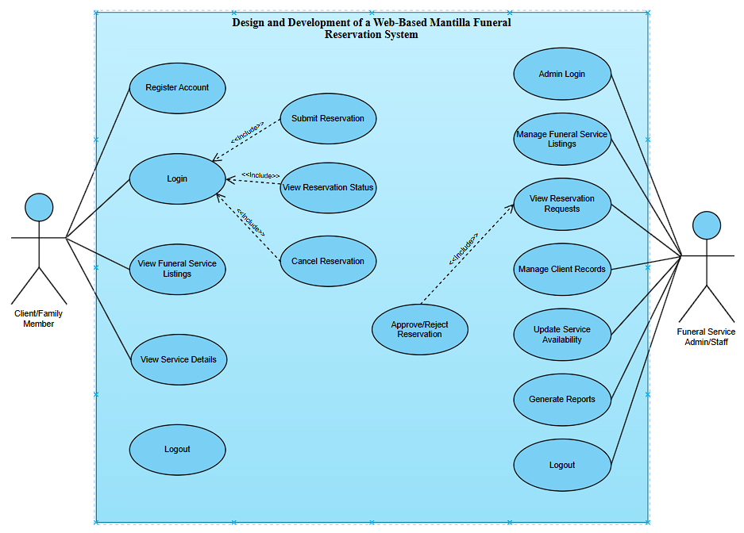
The use case diagram of the Web-Based Mantilla Funeral Reservation System shows the main interactions between the system and its two users: the Client/Family Member and the Funeral Service Admin/Staff. The client can register an account, log in, view funeral service listings, view service details, submit a reservation, check reservation status, cancel a reservation, and log out. On the other hand, the admin or staff can log in, manage funeral service listings, view reservation requests, approve or reject reservations, manage client records, update service availability, generate reports, and log out. Overall, the diagram presents how the system supports both client-side reservations and administrator-side management, making the funeral reservation process more organized, accessible, and efficient.
Figure 1. Use Case Diagram

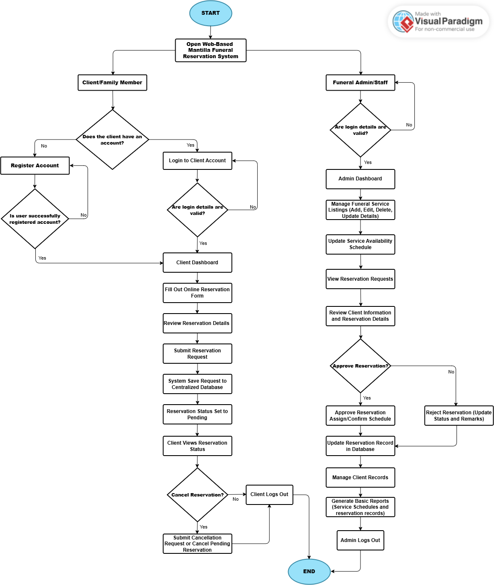
Flowchart

Figure 2. Flowchart
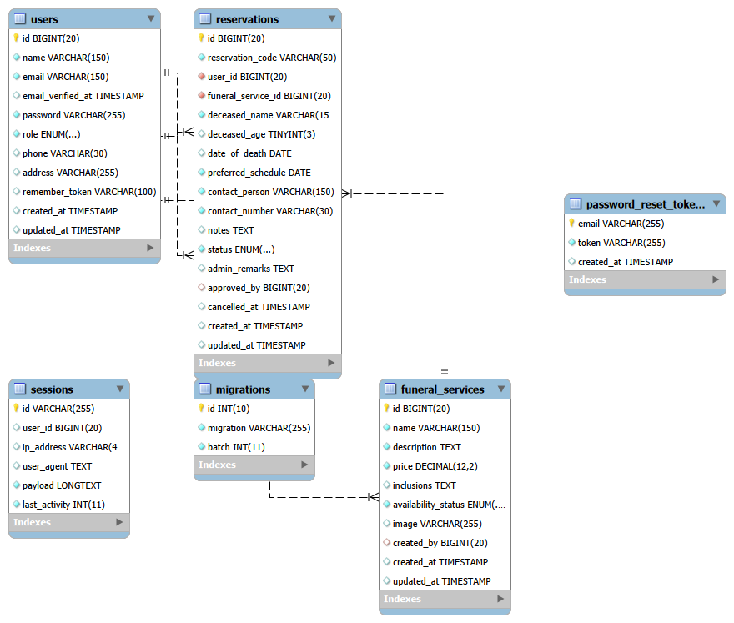
Entity-Relationship Diagram

Figure 3. ER Diagram

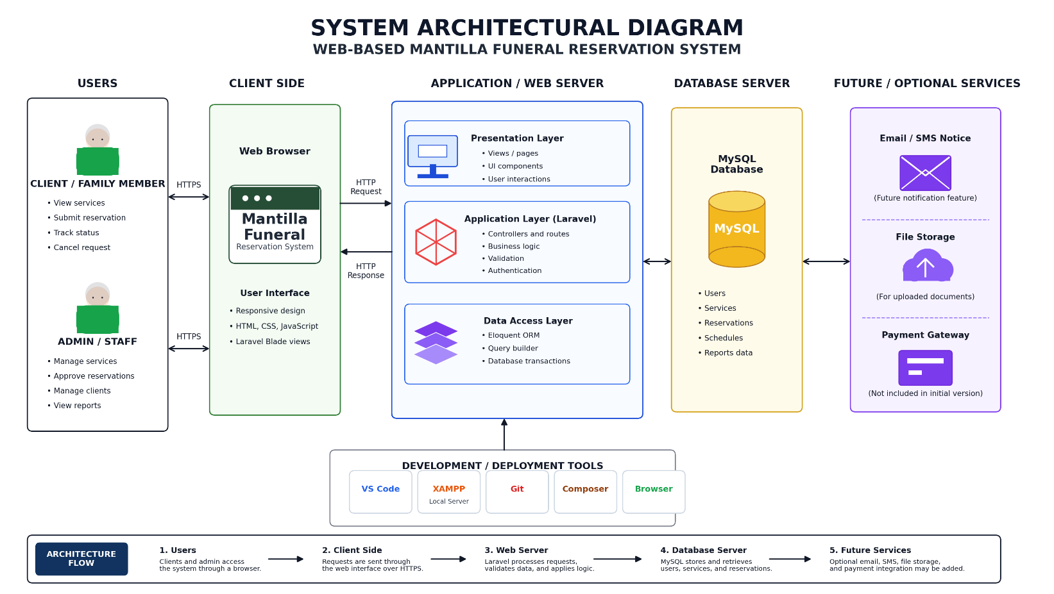
System Architecture Diagram

Figure 4. System Architectural Diagram

Interface Design
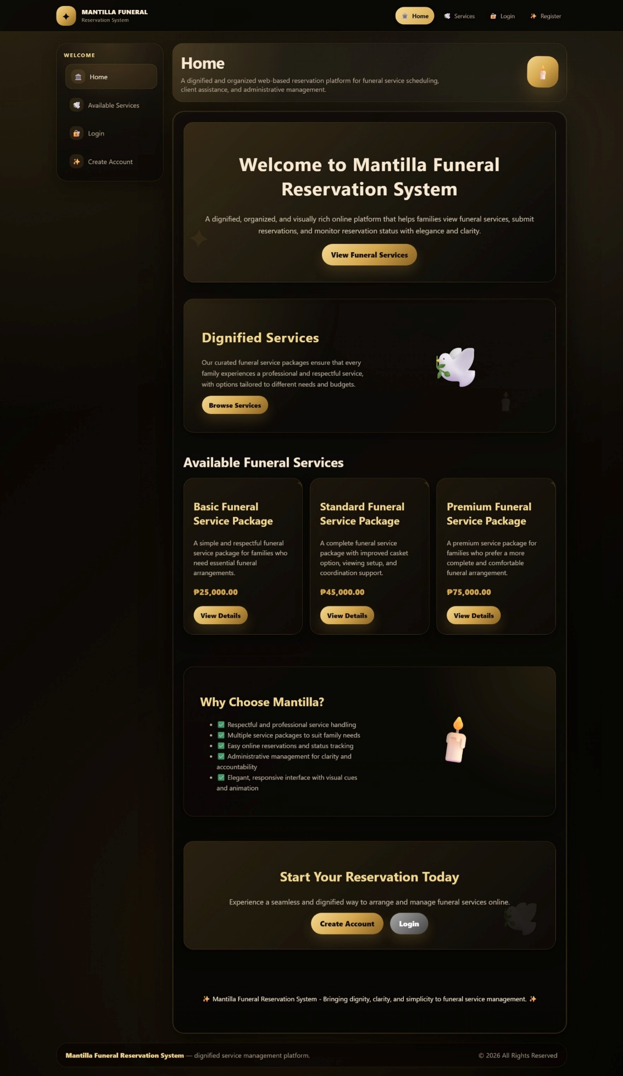
Figure 5. Main Page
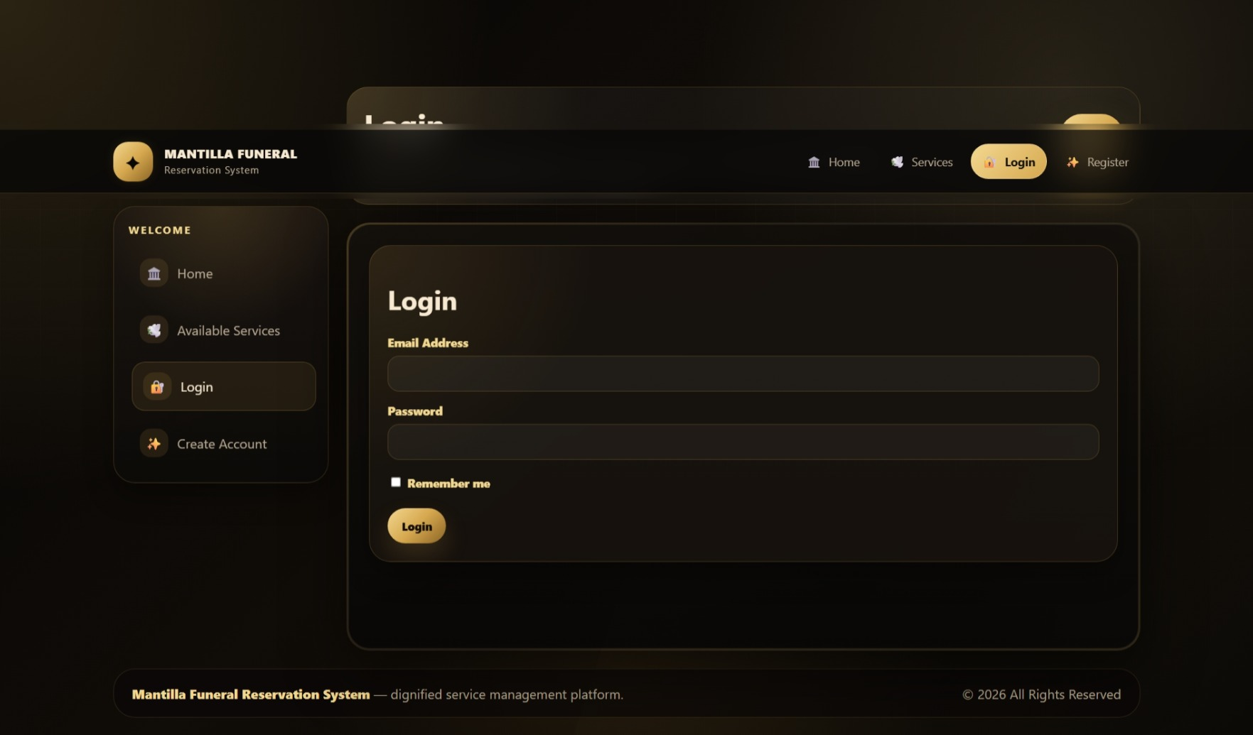
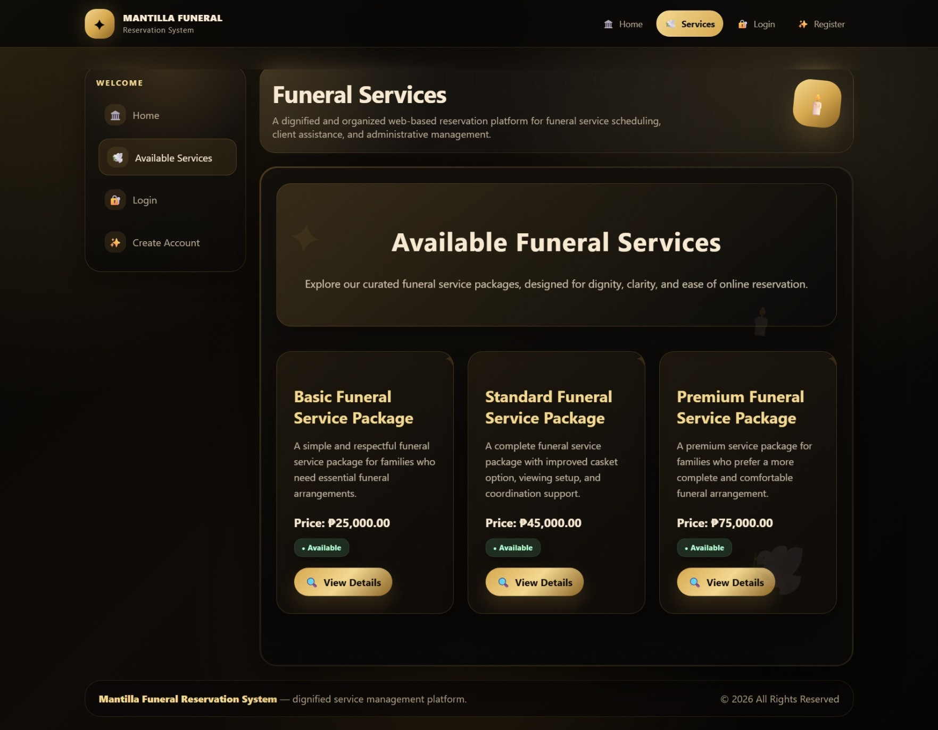
Figure 6. Available Services
Figure 7. Login
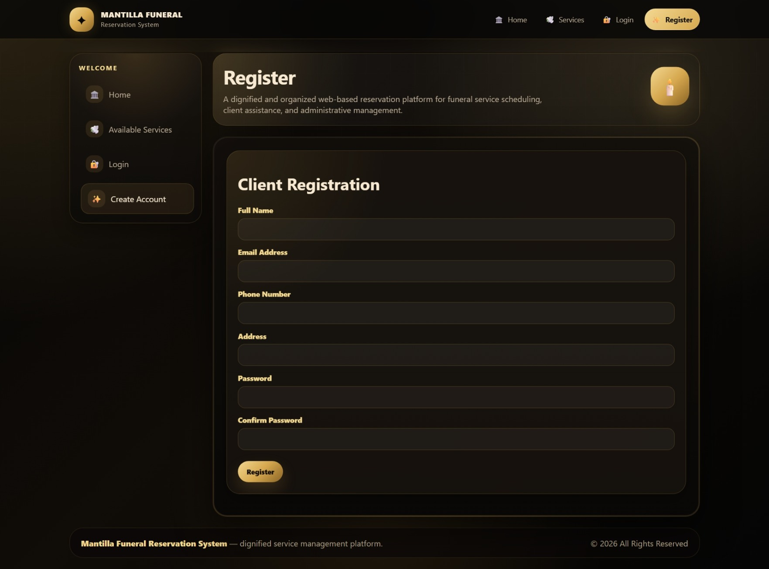
Figure 8. Register

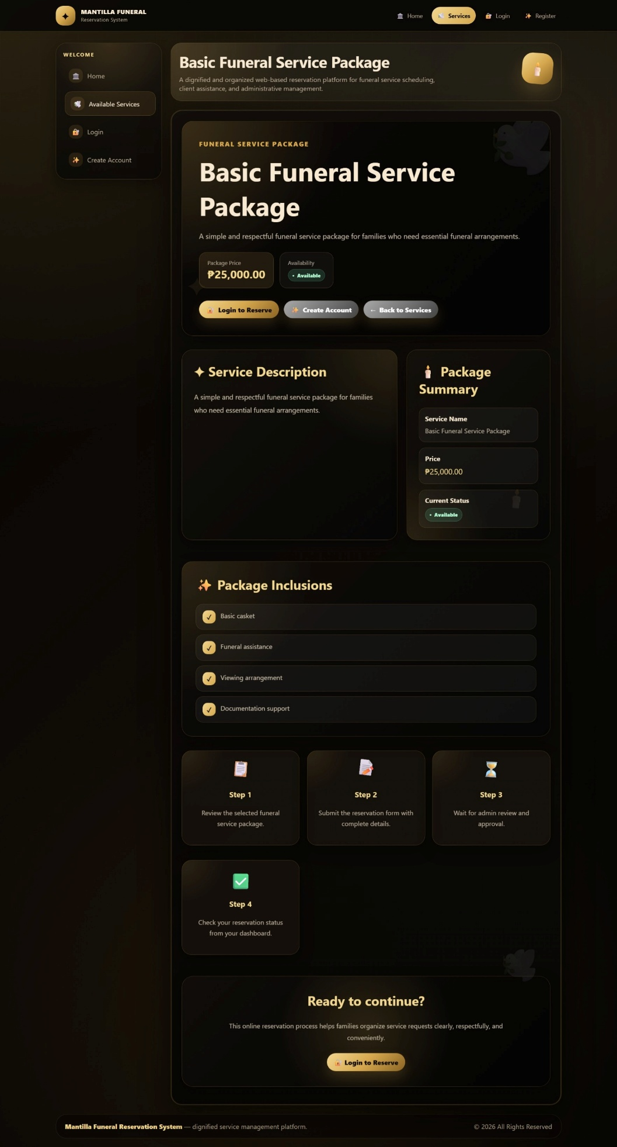
Figure 9. View Details

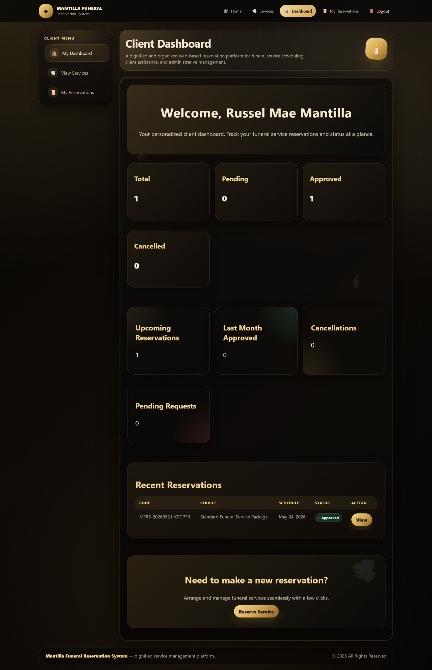
USER PANEL
Figure 10. Client Dashboard
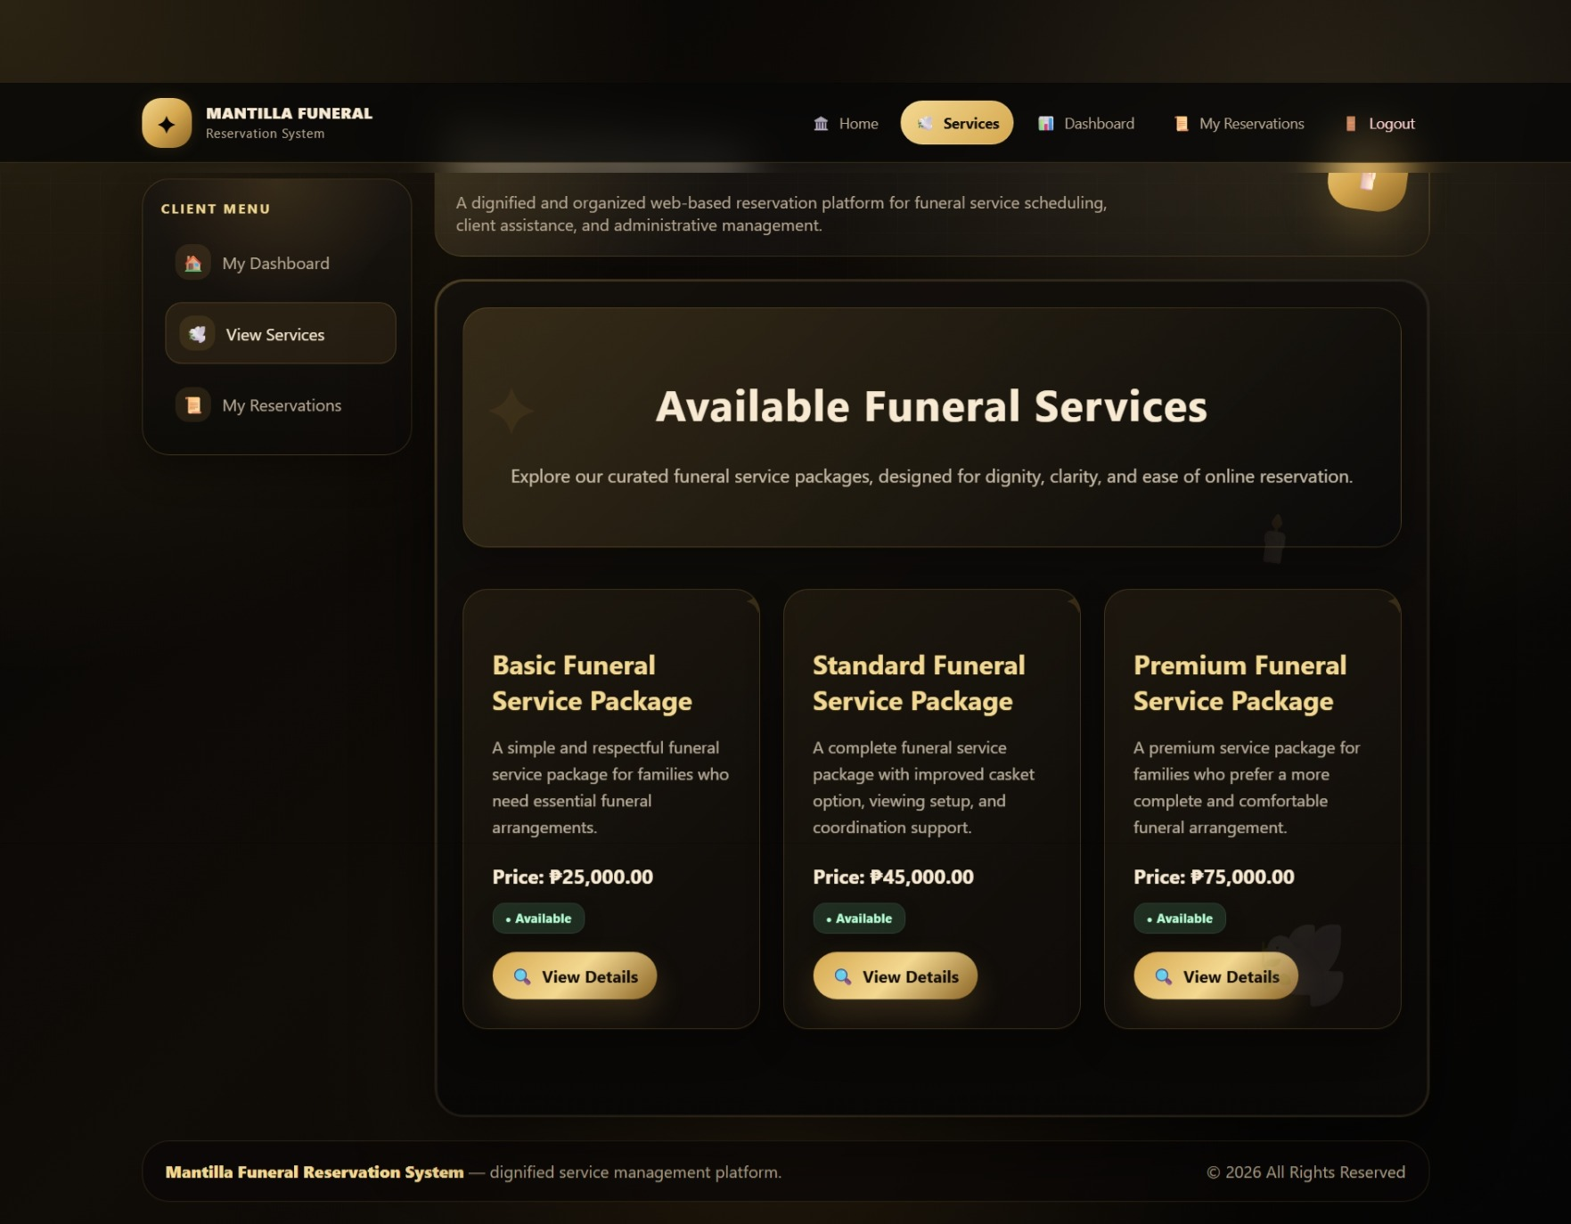
Figure 11. View Services
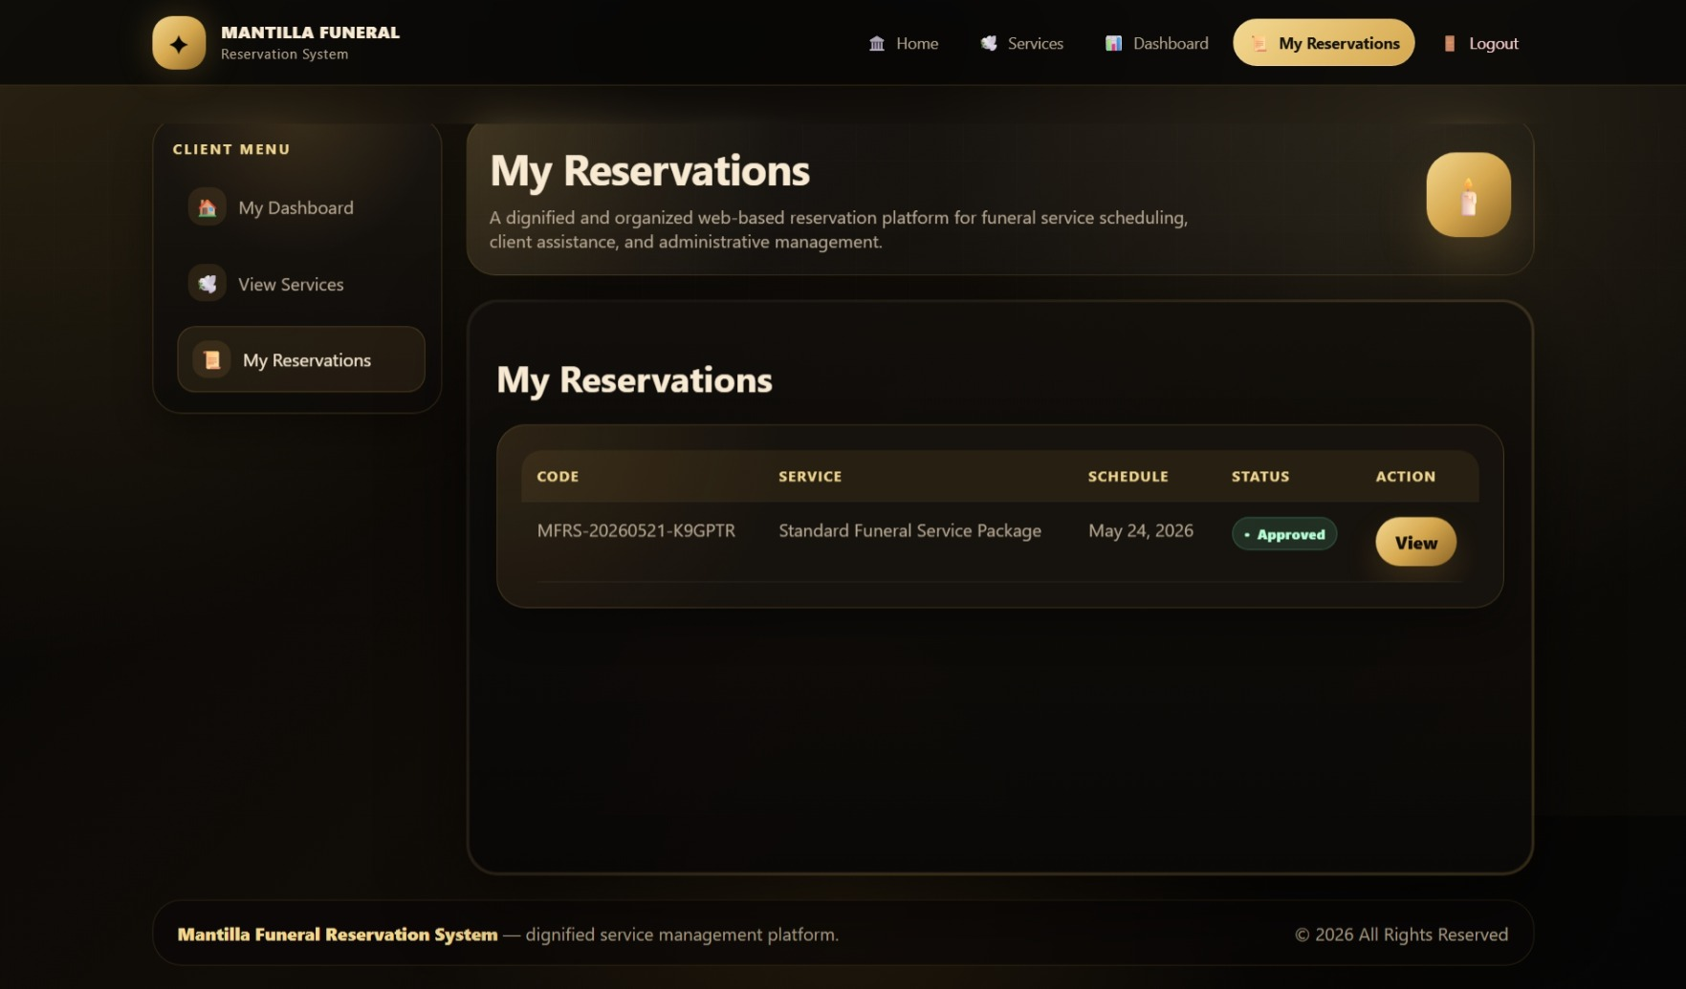
Figure 12. My Reservations
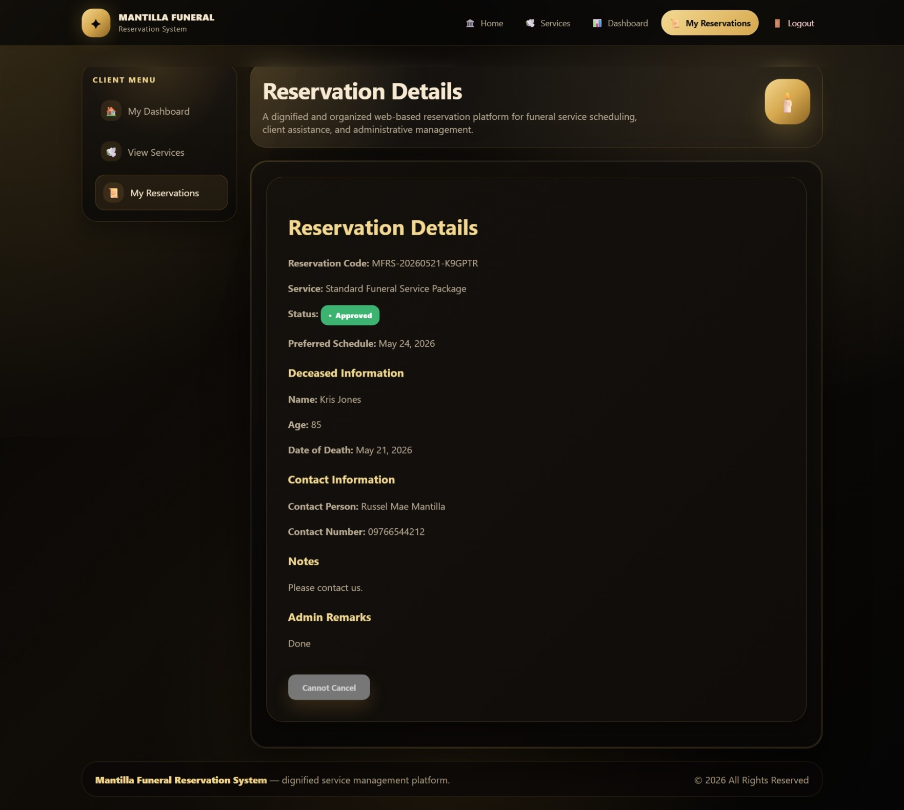
Figure 13. Reservation Details

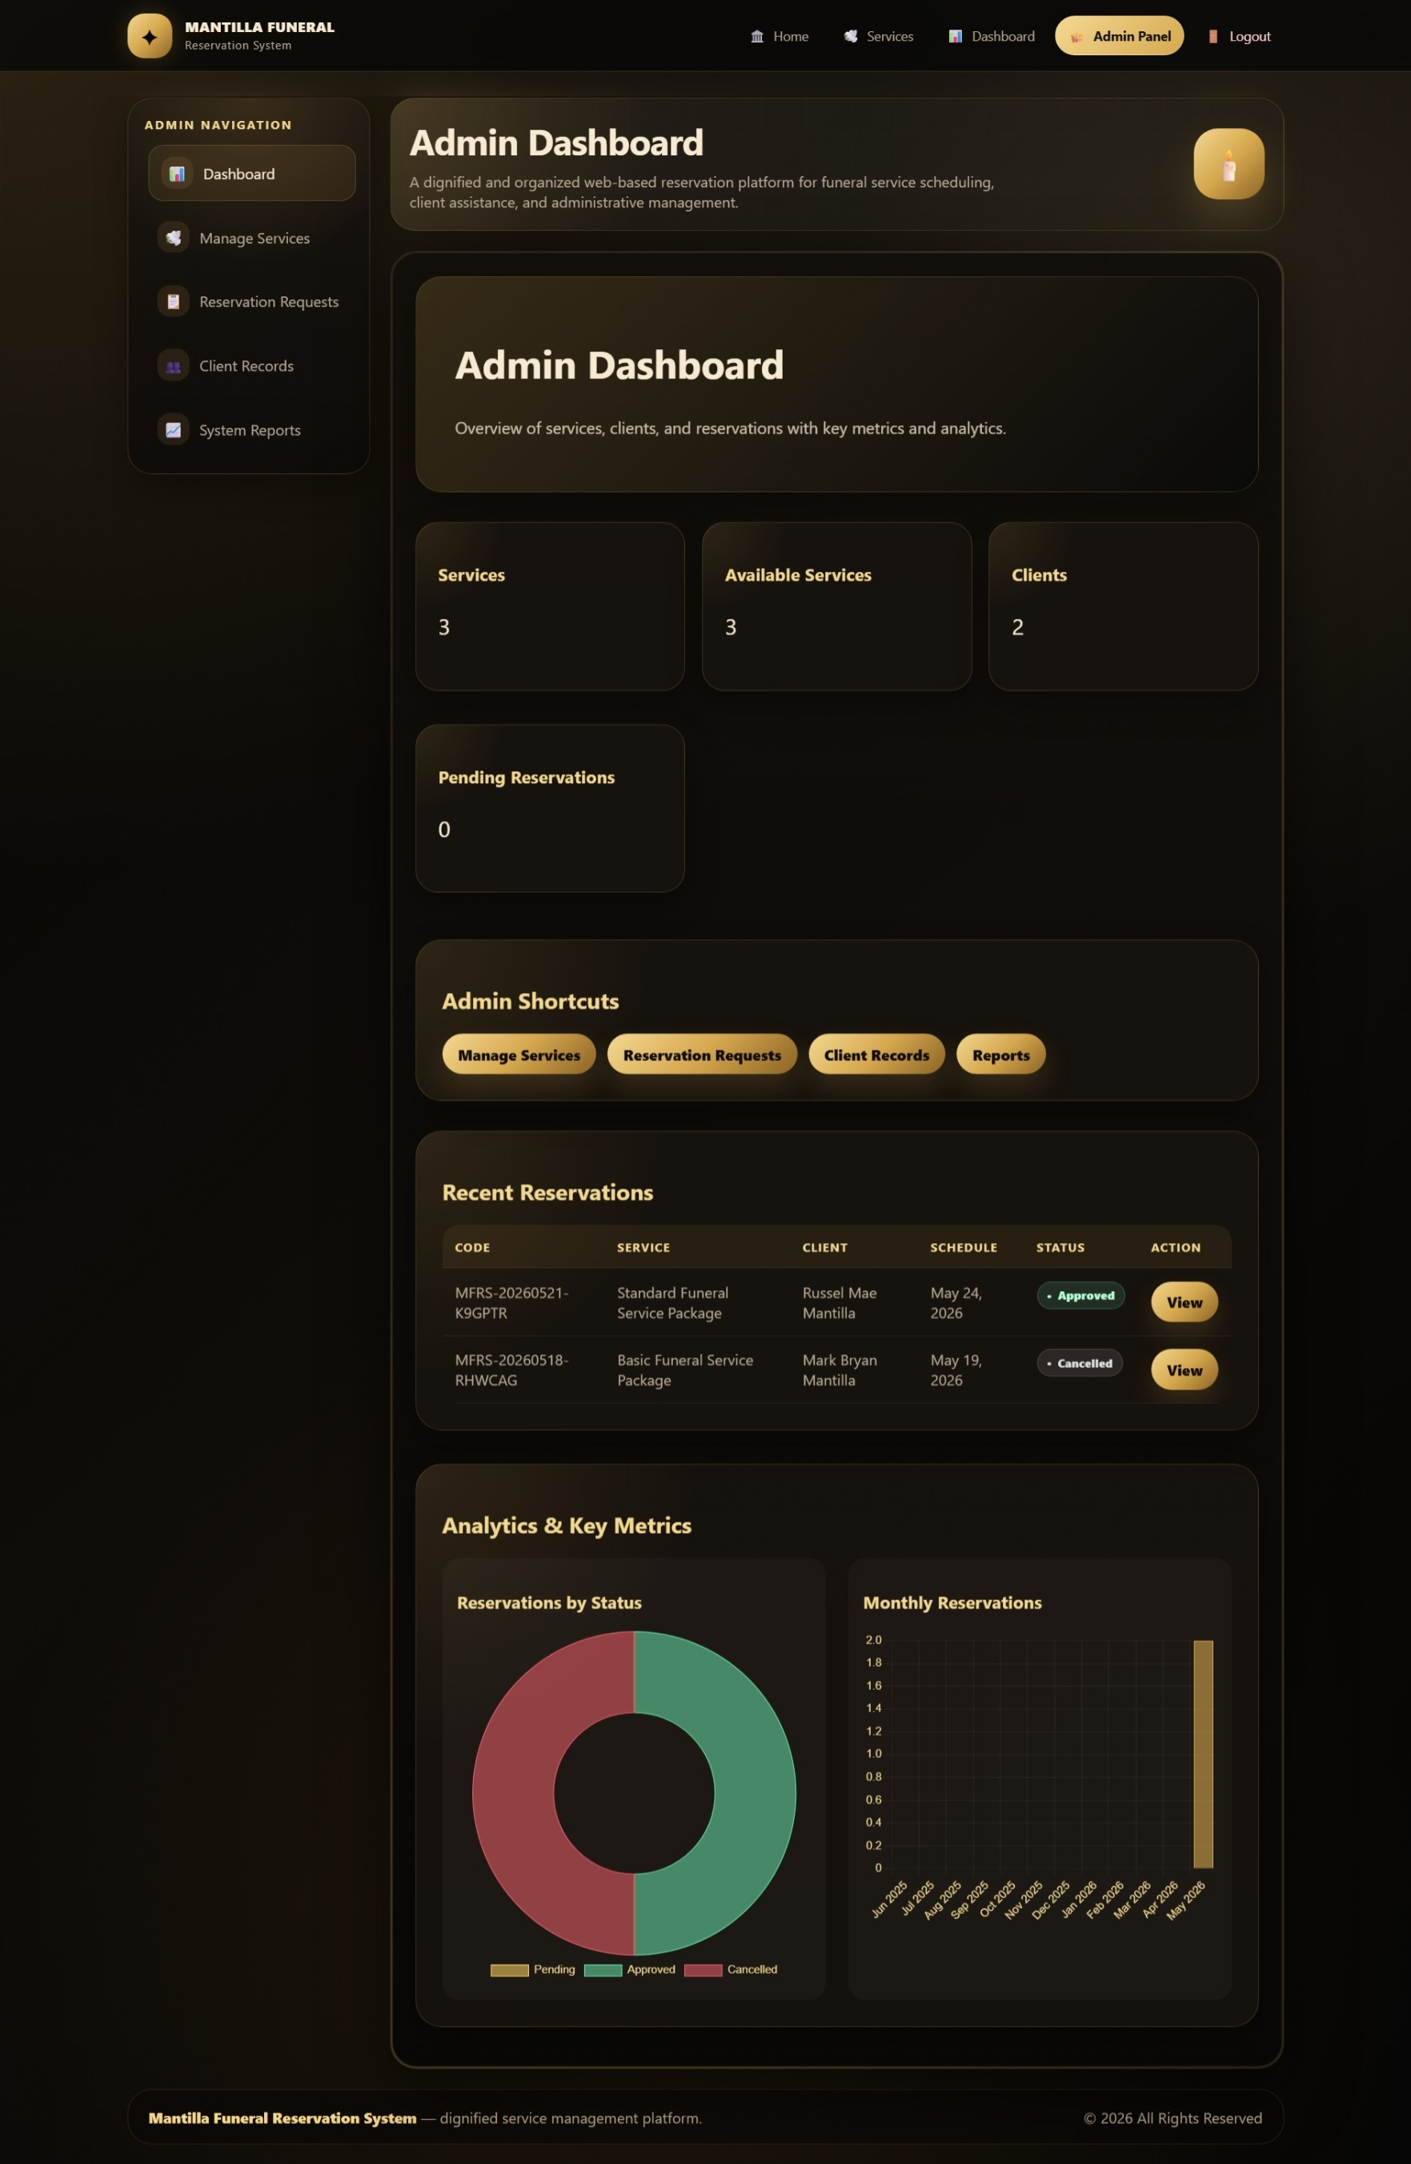
ADMIN PANEL
Figure 14. Admin Dashboard
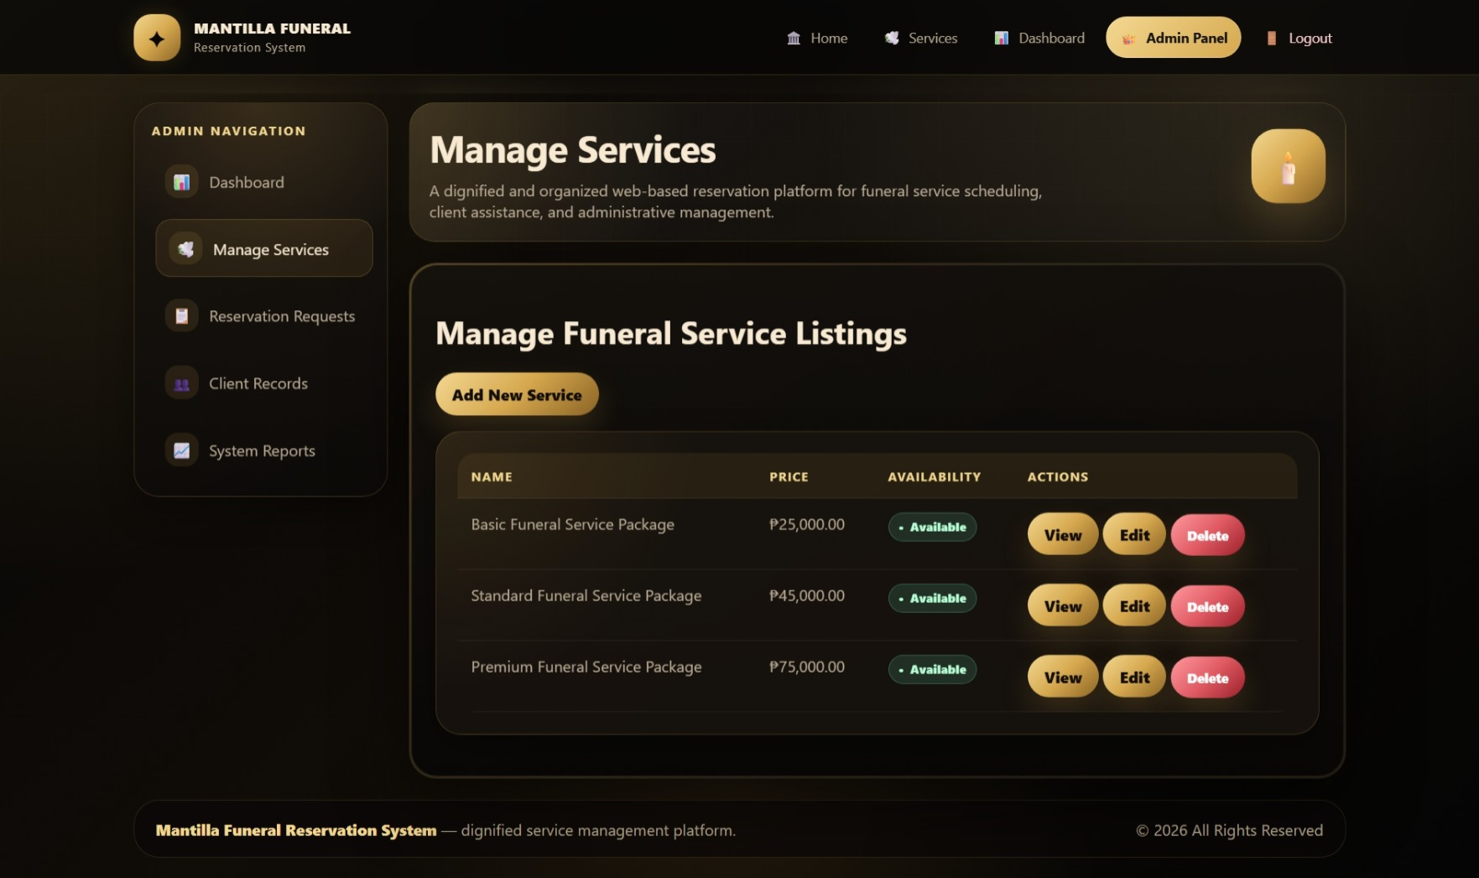
Figure 15. Manage Services
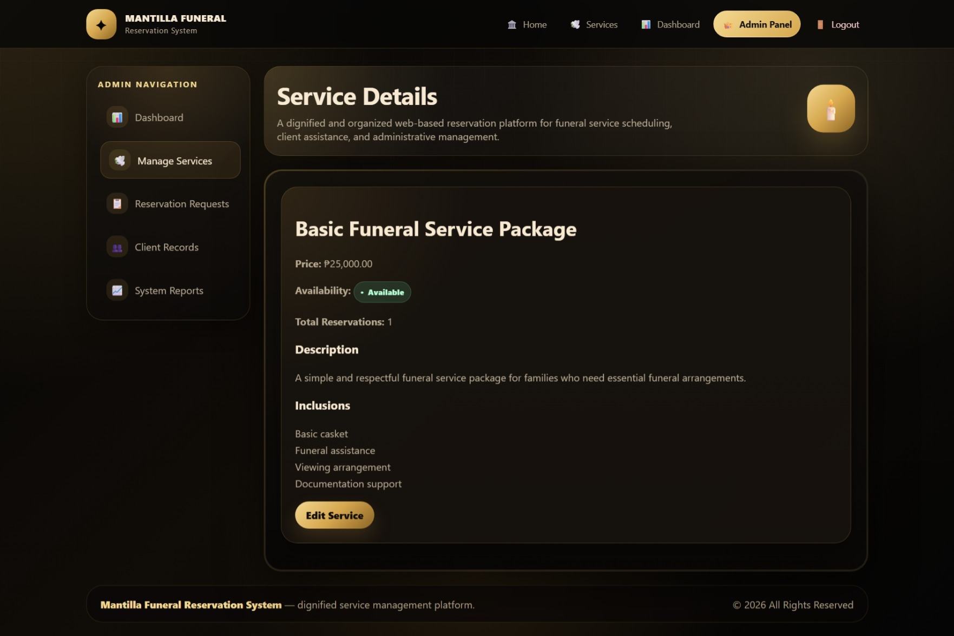
Figure 16. View Services

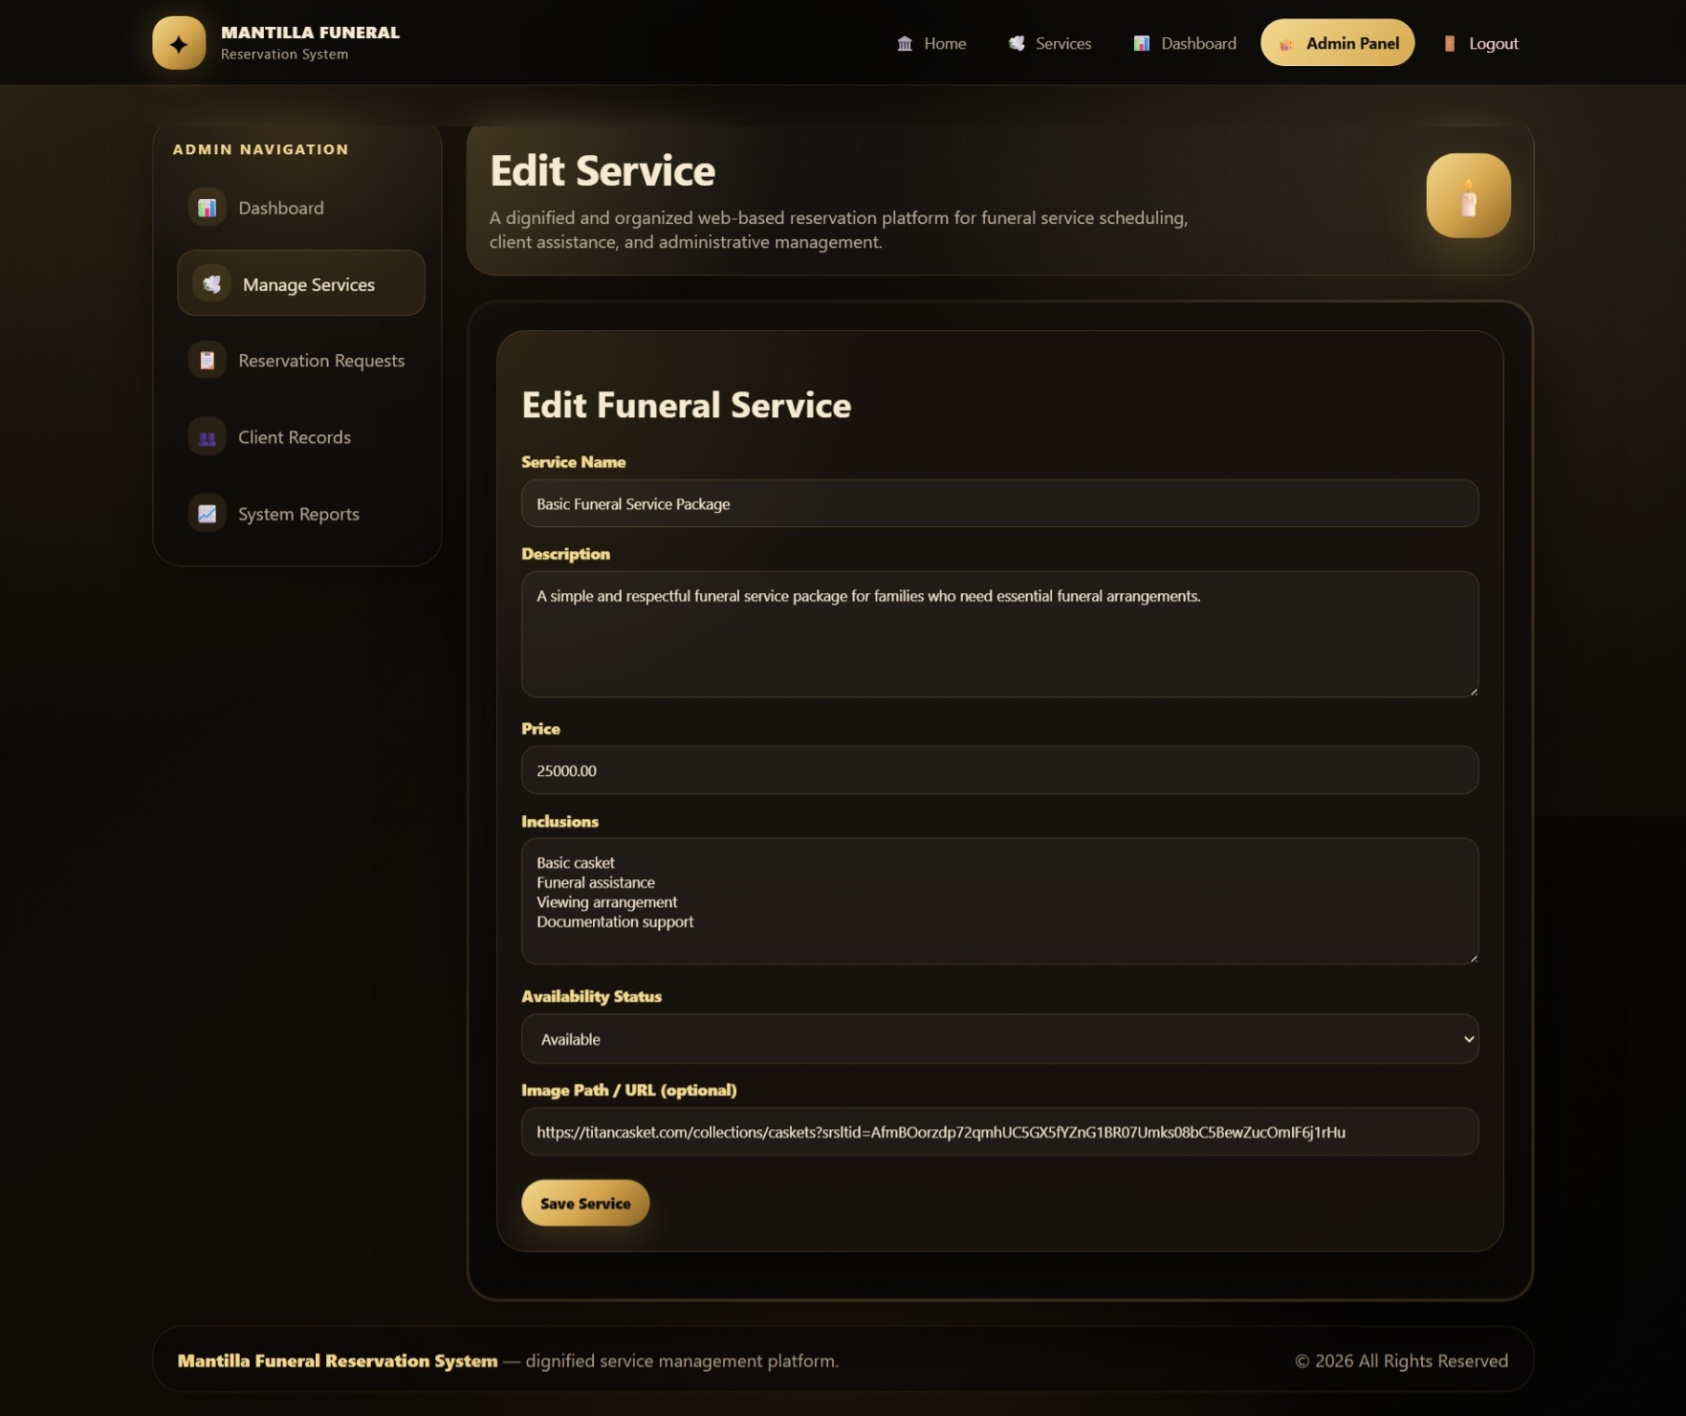
Figure 17. Edit Services

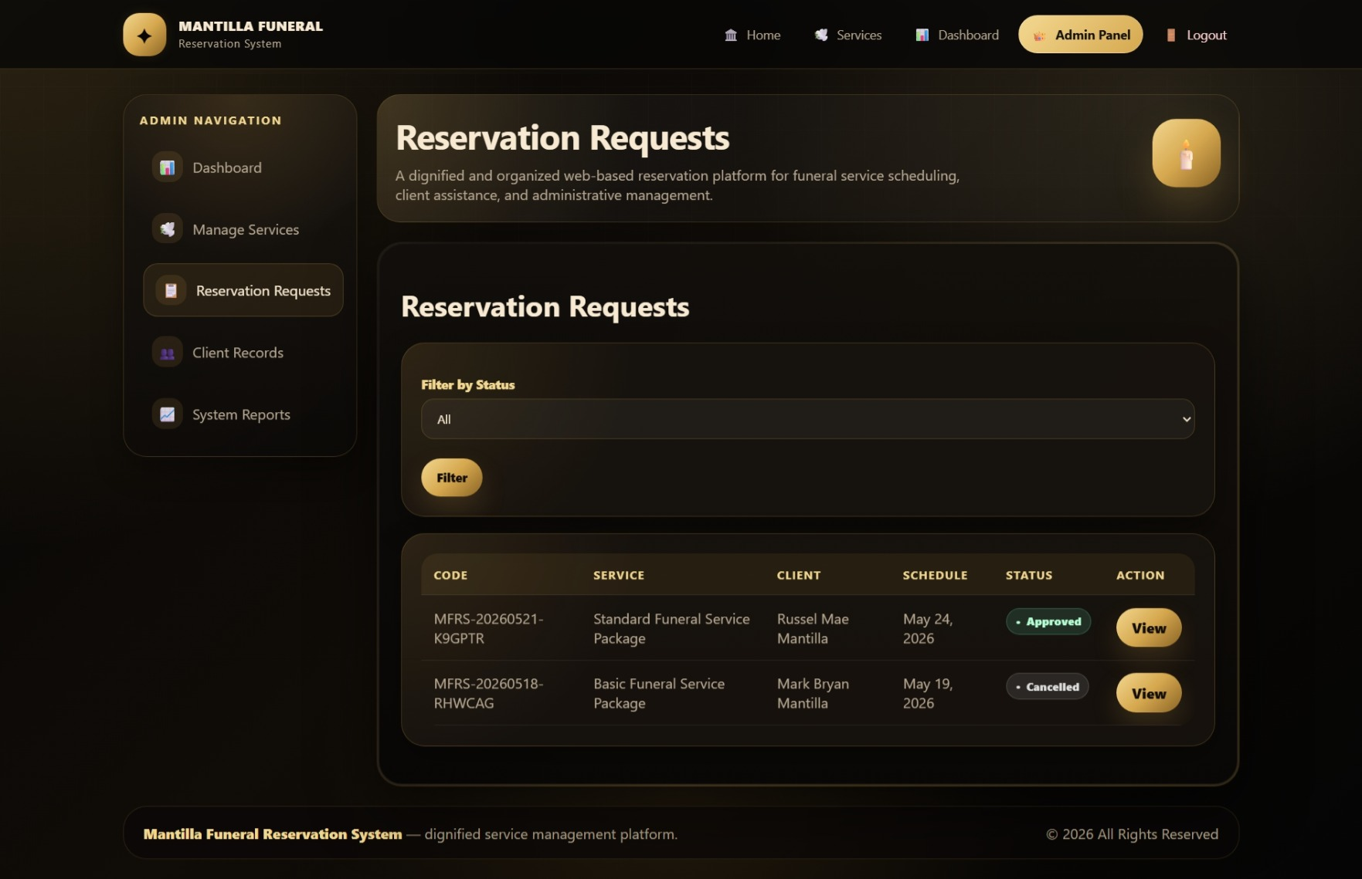
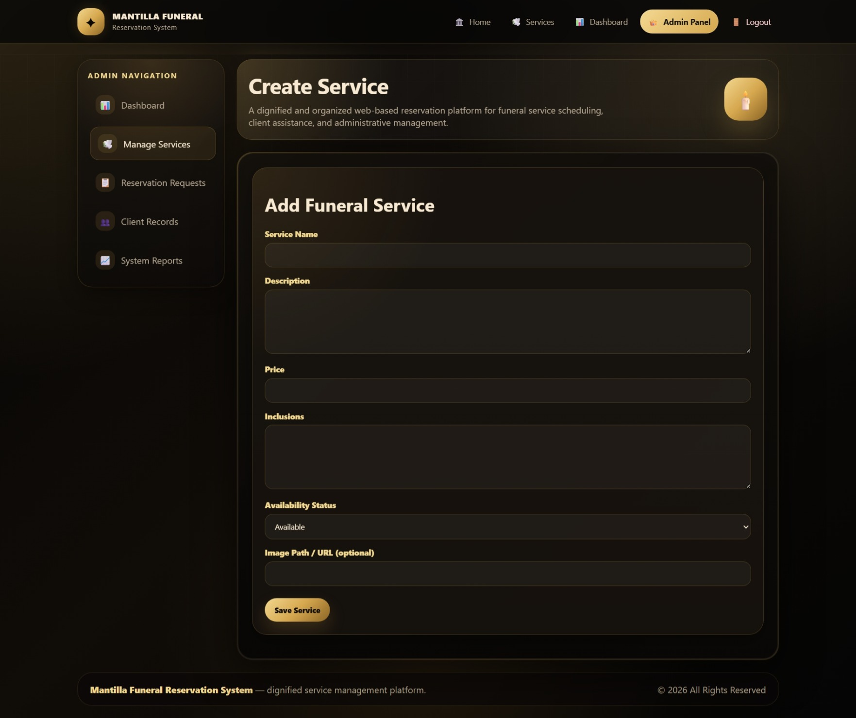
Figure 18. Add New Service
Figure 19. Reservation Requests
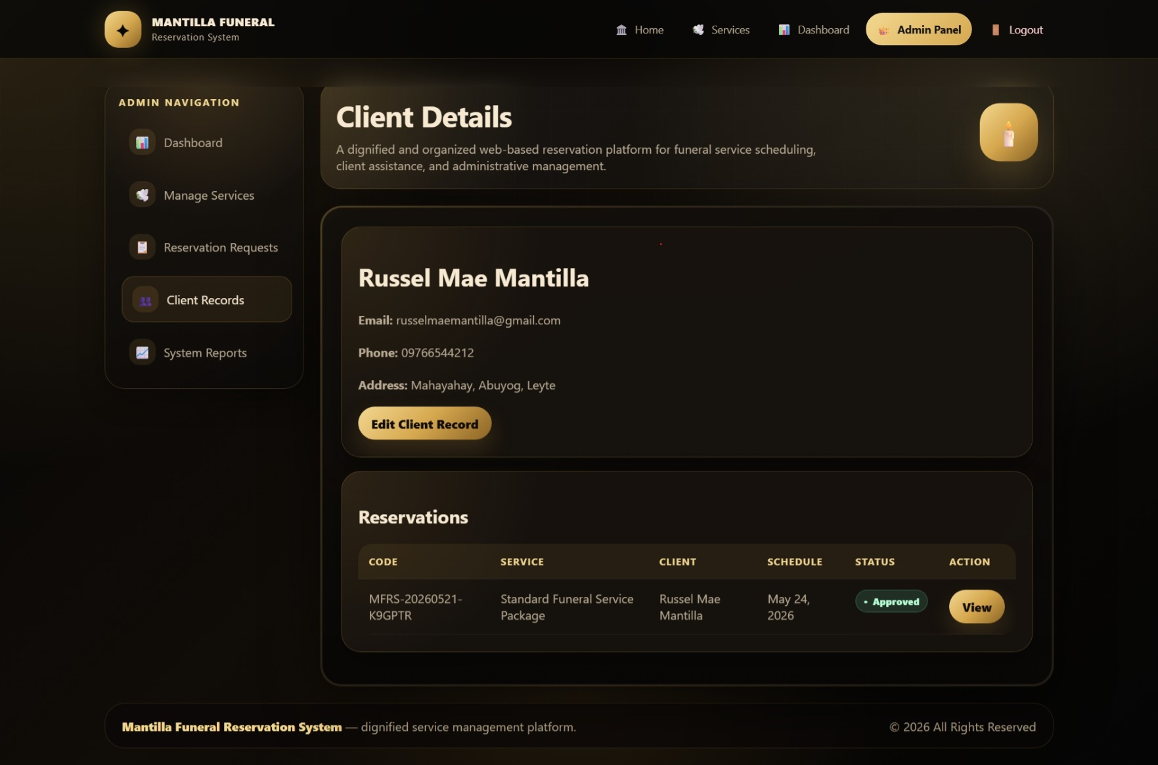
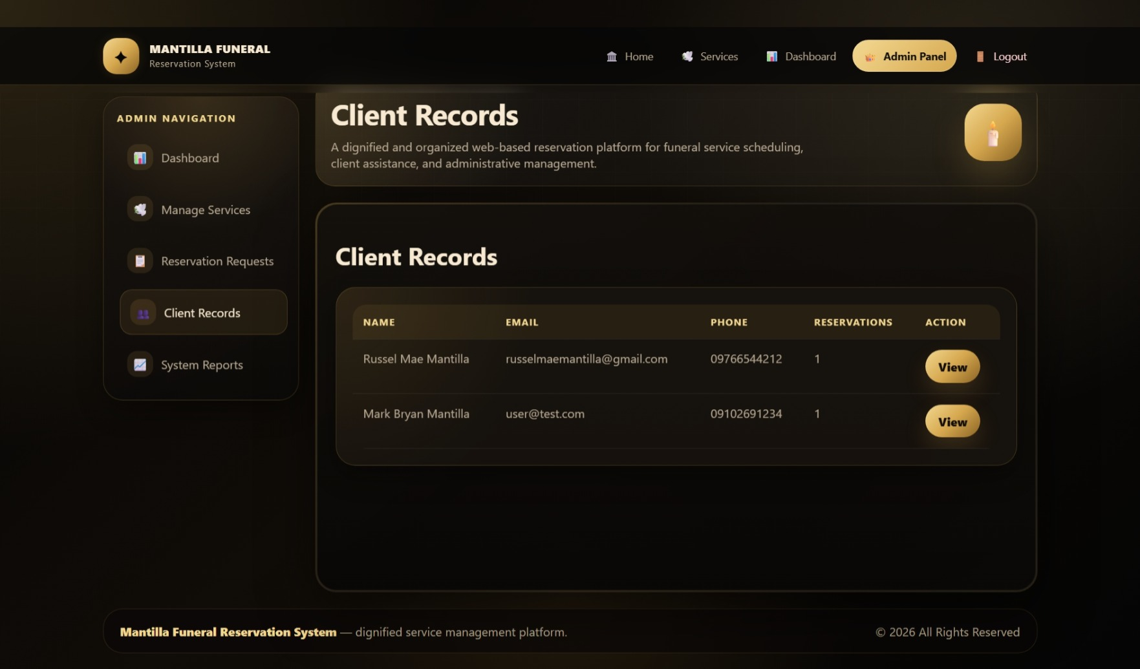
Figure 20. Client Records
Figure 21. Client Details

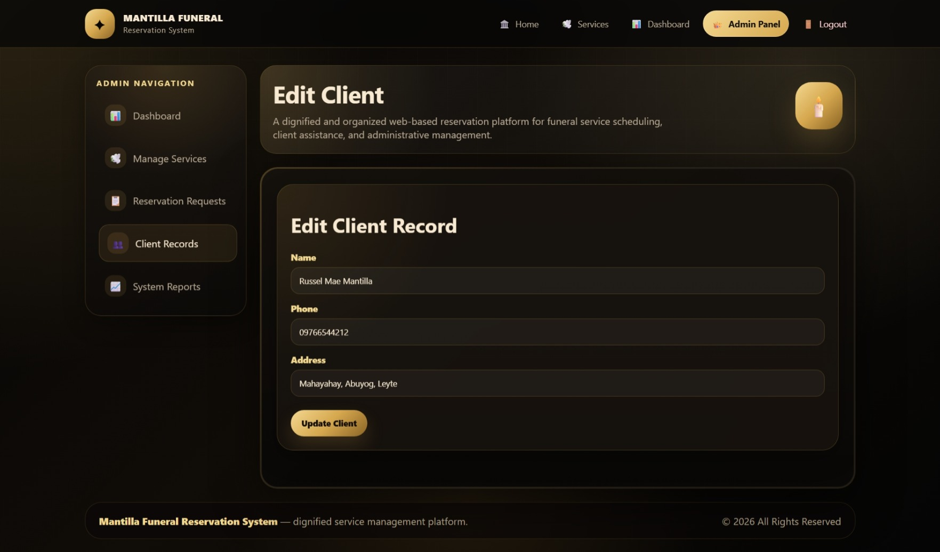
Figure 22. Edit Client

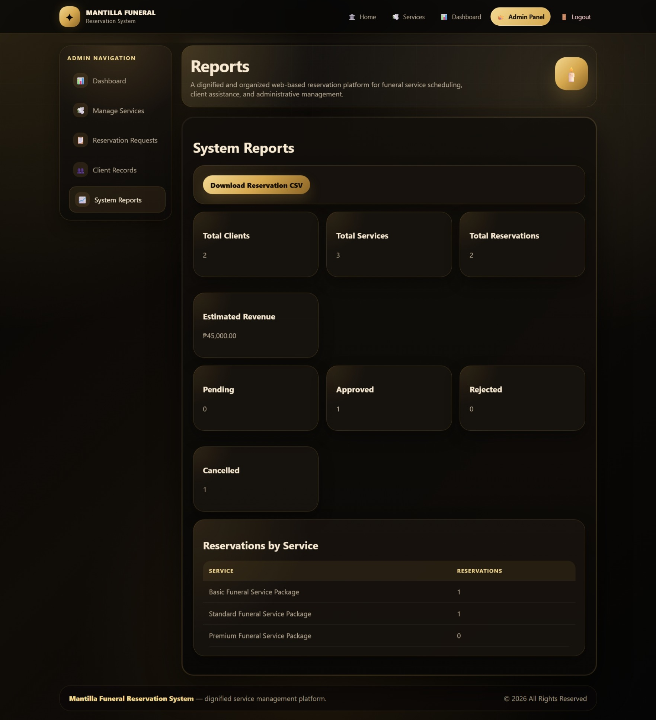
Figure 23. System Reports

DATABASE STRUCTURE
The database of the Web-Based Mantilla Funeral Reservation System is designed to store and manage user accounts, funeral service information, reservation records, login sessions, and password reset data. The main tables used in the system are users, funeral_services, reservations, sessions, and password_reset_tokens. These tables support the major functions of the system, such as client registration, service listing management, online reservation submission, reservation approval, and record monitoring.
List of Tables
Table Name | Description
users | Stores the account information of clients and administrators.
funeral_services | Stores funeral service packages, prices, inclusions, and availability.
reservations | Stores reservation requests submitted by clients.
sessions | Stores user session data used by Laravel during login activity.
password_reset_tokens | Stores password reset tokens for account recovery.
Table 1. List of Tables
users
The users table stores the account details of all registered users of the system, including clients and administrators.
Field Name | Description
id | Unique identification number of each user.
name | Full name of the user.
email | Email address used for login; must be unique.
email_verified_at | Stores the date and time when the email was verified, if applicable.
password | Encrypted password of the user.
role | Identifies whether the user is a client or an admin.
phone | Contact number of the user.
address | Address of the user.
remember_token | Token used by Laravel for “remember me” login sessions.
created_at | Date and time when the record was created.
updated_at | Date and time when the record was last updated.
Table 2. users
funeral_services
The funeral_services table stores the details of the funeral services or packages offered by Mantilla Funeral.
Field Name | Description
id | Unique identification number of each funeral service.
name | Name of the funeral service or package.
description | Detailed description of the service.
price | Price of the funeral service.
inclusions | List of items or services included in the package.
availability_status | Indicates whether the service is available or unavailable.
image | Optional image path or file related to the service.
created_by | Identifies the admin who created or added the service record.
created_at | Date and time when the service record was created.
updated_at | Date and time when the service record was last updated.
Table 3. funeral_services
reservations
The reservations table stores the reservation requests submitted by clients. It contains information about the selected funeral service, deceased person, preferred schedule, contact person, and reservation status.
Field Name | Description
id | Unique identification number of each reservation.
reservation_code | Unique tracking code assigned to each reservation.
user_id | Identifies the client who submitted the reservation.
funeral_service_id | Identifies the funeral service selected by the client.
deceased_name | Name of the deceased person.
deceased_age | Age of the deceased person, if provided.
date_of_death | Date of death of the deceased person, if provided.
preferred_schedule | Client’s requested schedule for the funeral service.
contact_person | Name of the person to be contacted regarding the reservation.
contact_number | Contact number of the client or contact person.
notes | Additional remarks or requests from the client.
status | Current status of the reservation, such as pending, approved, rejected, or cancelled.
admin_remarks | Remarks or comments from the administrator.
approved_by | Identifies the admin who approved or rejected the reservation.
cancelled_at | Date and time when the reservation was cancelled, if applicable.
created_at | Date and time when the reservation was submitted.
updated_at | Date and time when the reservation record was last updated.
Table 4. reservations
sessions
Field Name | Description
id | Unique session identification code.
user_id | Identifies the logged-in user, if available.
ip_address | IP address of the user.
user_agent | Browser or device information of the user.
payload | Stored session data.
last_activity | Records the user’s last activity in the system.
Table 5. sessions
password_reset_tokens
The password_reset_tokens table stores the data needed for password recovery.
Field Name | Description
email | Email address of the user requesting password reset.
token | Password reset token generated by the system.
created_at | Date and time when the reset token was created.
Table 6. password_reset_tokens

Relationship Between Tables
The users table is connected to the reservations table through the user_id field. This means that one client can submit one or more reservations, while each reservation belongs to only one client. The funeral_services table is connected to the reservations table through the funeral_service_id field, which means that one funeral service can be selected in many reservations, but each reservation is linked to only one funeral service. The users table is also connected to the funeral_services table through the created_by field, which identifies the administrator who created the service listing. In addition, the approved_by field in the reservations table links to the users table to identify the administrator who approved or rejected a reservation. The sessions table may also be linked to the users table through the user_id field to track login sessions. The password_reset_tokens table supports account recovery through the user’s email address. Overall, these relationships allow the system to organize clients, administrators, funeral services, and reservation records in a structured and reliable manner.

IMPLEMENTATION AND TESTING
The implementation of the Web-Based Mantilla Funeral Reservation System was carried out using PHP with the Laravel Framework, MySQL as the database, phpMyAdmin for database management, Visual Studio Code for coding, and XAMPP as the local development server. The development process started with planning the system features, user roles, and database structure. After identifying the needed modules, the database tables were created for users, funeral services, reservations, sessions, and password reset tokens. The system interfaces were then developed, including the registration and login pages, funeral service listing, reservation form, client reservation page, admin dashboard, service management page, reservation management page, client records, and reports page. Laravel routes, controllers, models, and views were used to connect the system functions to the database and to organize the overall structure of the application.
Several testing procedures were performed to check if the system functions properly. The login and registration features were tested to ensure that users could create accounts and access the system based on their roles. The funeral service listing was tested to confirm that service details such as name, price, description, inclusions, and availability could be displayed correctly. The reservation form was tested by submitting sample reservation requests and checking if the data was successfully stored in the database. The admin functions were also tested, including adding, editing, and deleting funeral services, viewing reservation requests, approving or rejecting reservations, managing client records, and generating basic reports. Database testing was also performed to verify that records were saved, updated, retrieved, and connected properly between related tables.
During development, some problems were encountered, particularly in database connection, routing, form validation, and role-based access. There were instances where pages did not load properly because of route errors or incorrect controller references. Some forms also needed proper validation to prevent incomplete or incorrect data from being submitted. Another issue was ensuring that clients and administrators had different access permissions, since the client should only access reservation-related pages while the admin should access management pages. Layout and interface adjustments were also needed to make the system more organized and easier to use.
The solutions applied included checking and correcting the Laravel route definitions, updating controller functions, and making sure that the models were properly connected to the database tables. The database configuration was reviewed through the .env file, and phpMyAdmin was used to verify whether records were being stored correctly. Form validation was improved to ensure that required fields were completed before submission. Role-based access was handled by separating client and admin functions, allowing each user type to access only the appropriate pages. The interface was also revised and tested repeatedly to improve navigation, readability, and overall usability. Through these procedures, the system became more functional, organized, and ready for presentation as a web-based funeral reservation system.

CONCLUSION
The Web-Based Mantilla Funeral Reservation System successfully achieved its goal of providing an organized and accessible platform for managing funeral service reservations. Through the system, clients can register an account, log in, view funeral service details, and submit reservation requests online. On the administrator side, the system allows staff to manage funeral service listings, monitor client reservations, update reservation status, manage client records, and generate basic reports. These features help reduce the need for manual processing and make the overall reservation process more systematic.
The system provides several benefits for both Mantilla Funeral and its clients. For clients, it offers a more convenient way to inquire and reserve funeral services without relying only on physical visits. For the staff, it helps improve record management, reduce errors, organize reservation schedules, and provide faster access to important client and service information. Since funeral services are often time-sensitive and emotionally difficult for families, the system supports a more reliable and efficient process that can help lessen confusion and delays.
During the development process, important learning was gained in designing and building a functional web-based system using PHP, Laravel, MySQL, phpMyAdmin, Visual Studio Code, and XAMPP. The project helped improve understanding of database design, system routing, user authentication, form handling, role-based access, and testing procedures. It also showed the importance of planning, debugging, and continuous testing in developing a system that is organized, usable, and aligned with the needs of its users. Overall, the project demonstrated how technology can be used to improve service operations and provide a more professional reservation management process.

RECOMMENDATIONS
For future improvements, it is recommended that the Web-Based Mantilla Funeral Reservation System be enhanced by adding more automated and user-friendly features. One possible improvement is the integration of an online payment gateway, such as GCash, Maya, or bank transfer options, so clients can conveniently settle reservation fees through the system. This would make the transaction process faster and more complete, especially for clients who cannot visit the funeral service provider immediately.
It is also recommended to add an SMS or email notification system to improve communication between Mantilla Funeral and its clients. Through this feature, clients can automatically receive updates about their reservation status, approval, rejection, schedule confirmation, or cancellation. This will help reduce the need for manual follow-ups and will make the reservation process more convenient and transparent.
Another suggested enhancement is the development of a mobile application version of the system. Although the current project is web-based, a mobile application can provide easier access for clients who prefer using smartphones. This can improve accessibility and allow users to submit reservations, check service details, and receive updates anytime and anywhere.
The system may also be improved by adding advanced report generation features. Future versions may include monthly sales reports, service demand reports, reservation trends, and client transaction history. These reports can help the management analyze business performance, monitor service availability, and make better operational decisions.
Lastly, it is recommended to improve the system’s overall security and backup features. This may include stronger account authentication, regular database backup, activity logs, and data protection measures. Since the system stores sensitive client and reservation information, improving security will help protect user data and ensure the reliability of the system. Overall, these enhancements can make the system more complete, efficient, secure, and beneficial for both Mantilla Funeral and its clients.

